2-LED flipflop with 2 NPN transistors – how it works step by step
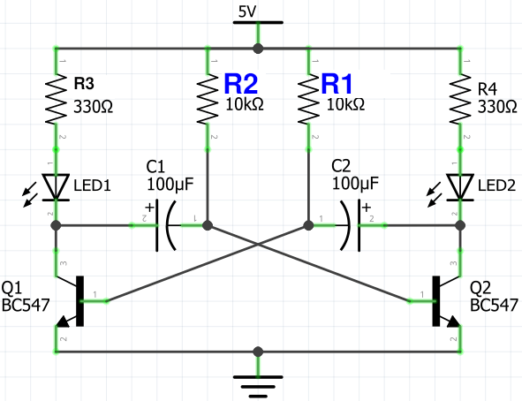

(values here are representative, not same
as in the soldering project)

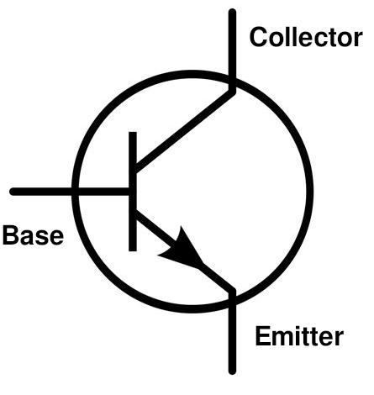

Step 1: Power ON
- Both capacitors are initially uncharged.
- A small imbalance causes one transistor (say Q1) to turn on slightly faster.

Step 2: Q1 Turns ON
- Q1 conducts → LED1 lights up
- Collector of Q1 goes low → this pulls base of Q2 low (via C1)
- Q2 stays OFF → LED2 is off
- Meanwhile, C1 charges through R2 (base resistor of Q2)

Step 3: C1 Charges Up
- Once C1 is charged, Q2 base is no longer held low
- Q2 starts to turn ON
- As Q2 turns ON, its collector goes LOW → this pulls base of Q1 low via C2
- Q1 turns OFF → LED1 goes off
- LED2 now lights up

Step 4: Repeat the Cycle
- C2 begins charging through R1
- When C2 charges enough, Q1 turns ON again
- Cycle continues indefinitely: LED1 and LED2 blink alternately

Blinking Speed
- Controlled by the values of capacitors (C1 & C2) and base resistors (R1 & R2)
- The flash rate is determined by the RC time constant t≈0.7×R×C Where:
R is the base resistor (e.g., 10kΩ)
C is the capacitor (e.g., 47µF)

(The collector resistors R3 and R4 serve to limit current through LEDs but don’t affect blink rate appreciably)

